# Exercise: CSS Overview

## Problem 1. Link .html with .css

You’ll be given the html and the style sheet. Your task is to link correctly the files. Final result should be like image below. 100% accuracy is required.

Constrains: You are NOT allowed to change the CSS file.

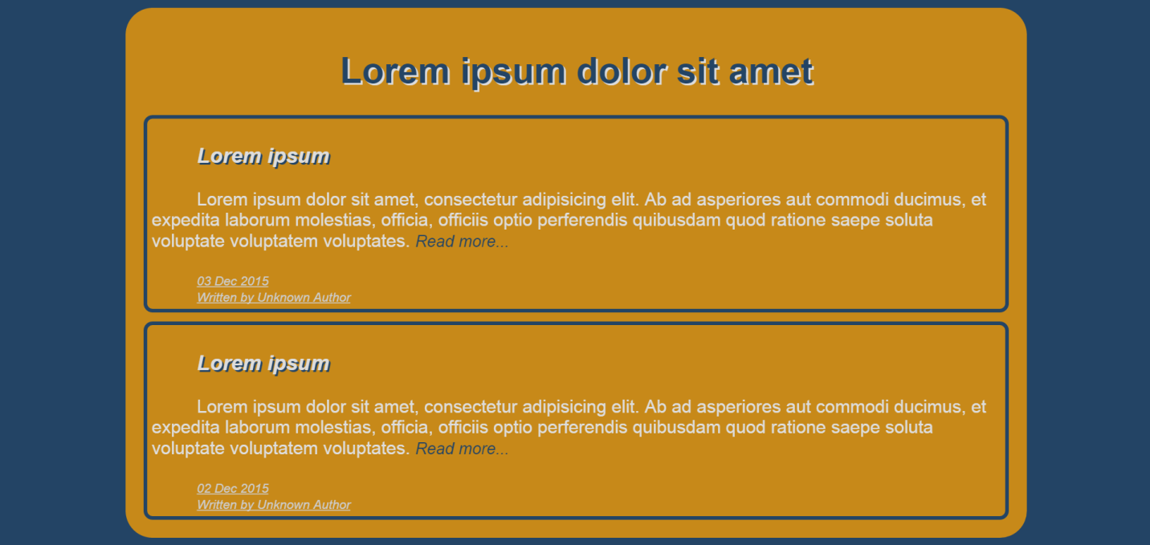

### Step 1. Link the style sheet

You should add a tag <link> as a head element. The <link> tag should have attributes for relation and one that specifies the location of the linked document.

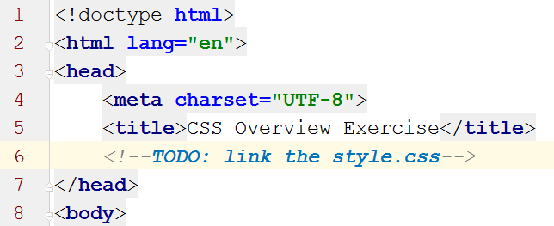

### Step 2. Get to know the style sheet

Before applying any changes to the html, you need to study style.css and figure out how it works.

### Step 3. Add missing attributes

After you get to know the style sheet add the missing attributes in the html tags.

For example: there’s a selector for element with id “wrapper”. As we know the wrapper is the main container which holds the whole page. You should add attribute for the <div> tag in the body of the page.

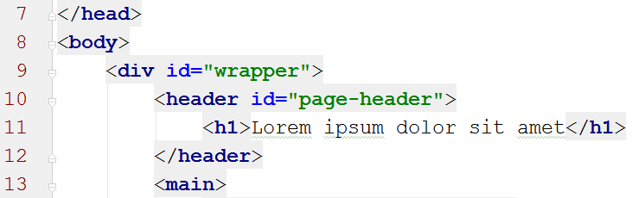

Do the same for any other tag where needed. Be careful which attribute you need “id” or “class”.